**Questions towards Jibestream as preparation for meeting / Teams session Tuesday 18th Feb 14.30 – 16.00 CET.**

- Is the main functionality of your application focused on floor plan management / store layouts?

Yes. Main functionality is to provide a platform for indoor mapping and work with one of the ecosystem partners to incorporate real-time indoor location and positioning services.

Various capabilities which include

* wayfinding and indoor navigation
* seamless outdoor maps to indoor maps
* asset tracking with the combination of indoor positioning service
* customized user profile mapping to display different layers of indoor map to different users
* geo fencing and security
* BI & Analytics

- How can people access the application and from what device?

Multichannel

* Web
* Kiosk
* Mobile App

Jibestream’s platform is offered through our native SDKs (Web, iOS, Android), RESTful APIs, and our Content/Venue Management System. Typically, Web and Kiosk applications are developed using our Web SDKs, and iOS and Android SDKs for their respective operating systems. Some of our clients also use our Web SDKs to build hybrid mobile apps using frameworks such as PhoneGap, Cordova, etc.

Flexibility to use IKEA UX

- Is there a way to integrate with other solutions within your application?

Dependent on Application

* Supports API
* Confirms that Jibestream needs to be the SOT for Maps and cannot consume maps from any other source like Revit
* If Revit supports, Jibestream can provide input maps to Revit
* However, can refer the existing floor plans (in PDF etc) and build source repository for indoor maps
* Supports integration with many Bluedot Position Services

- Does / (How) the application support customer guidance (directions)?

Jibestream provides the platform for accurate indoor mapping which can potentially include store floor plan, elevators, stairs, facility areas, products in the racks in the specified floor area etc. So a customer guidance in the form of how to reach from point A to point B inside the store is already there. But tracking the actual location of a customer and then helping her find a product and assisting her to the destination needs a solution based on a combination of IPS(Indoor Positioning Services). This can be integration with a third party blue dot company, WIFI, beacons, using the customer’s smartphone etc . Please elaborate more if needed.

Jibestream is also agnostic to Indoor Positioning Systems and has worked with several different positioning technologies including BLE, UWB, Ultrasound, Geomagnetic, etc. On the hardware side, our platform has been successfully integrated with hardware such as Aruba APs, Cisco CMX, Mist Systems, Siemens Enlighted smart lighting system, and many more.

- How many users can simultaneously edit a layout

Jibestream website mentions customized user profile mapping to display different layers of indoor map to different users, however we need to check on the capability of concurrent Edit operations on map.

One input is there is no versioning supported, so need to check on the archival process.

Only one user is able to edit the map at one time. For versioning, although we don’t support versioning within our platform, there are many ways to do it using tools such as GitHub, Power BI, etc.

We can discuss this during our call so we can understand how best we can support you with versioning.

- How customizable are the store layouts in terms of visualization (colors , fonts)?

Full, Jibestream showed how to modify the underline code in their demo.

- What costs are involved in creating the map, updating the map and potential fixed fees?

Area based.

**Map Creation**:There is a one-time cost associated with the process of map creation. After the POC, we recommend that multiple venues are digitized at the same time in order to be efficient with time and resources, and hence a lower cost. For example, with Ingka, we are starting with 27 malls simultaneously. The cost will be on a “per store” or “per sq. meter” basis.

**Software Subscription**: This is an annual cost for licensing our software. Besides the software, this includes cloud hosting on Microsoft Azure as well as customer success and support.

**Other costs:**

When you are first integrating our platform with your applications, you will need dedicated support from our engineering and solutions team. Our clients usually purchase a bucket of hours from us as per below:

* 25 hours - $5,000
* 50 hours - $9,000
* 100 hours - $17,500

- How much time is needed to create a new map and get it up and running?

Please elaborate.

The answer to this question depends on what resources are available. Our preferred file format is CAD as either dwg or dxc. However, we have also worked with other formats such as pdf, jpg, png, etc.

If the CAD files are available, we can create a new map in a couple days. In the past, we have digitized 145 malls in 75 days.

- Do you support working on multiple layers?

Yes

- Is data for store layouts stored in the cloud? Can / how do we consume it?

Not discussed, please elaborate.

- Have you done any wayfinding solutions using Revit as the source of the layouts?

Please elaborate. Eg. What you need as an input to make it work.

It looks like Revit can generate CAD files, which would be perfect. If not, we have worked with other varieties of files and we can investigate what file formats you currently have.

- If we would like to engage you in a proof of concept, what’s your lead-time from receiving Statement of work until real work can start?

Please elaborate.

Usually we can start within 5 – 8 days from receiving the Statement of Work.

- Your initial solution ideas integration towards IKEA’s SLM solution?

Pending discussion with SLM, TBD.

Separate discussion ongoing on SLM.

- Have you any integrations in Jibestream to automatically integrate maps from another source like Revit? (if the source have been updated?)

No, Jibestream need to act as source in case of Revit. Please elaborate your experience with other (non-Revit) source systems.

Discussed before.

**Additional questions**

* What is the underlying technology beneath Jibestream? Does it have both on-prem & cloud variants?

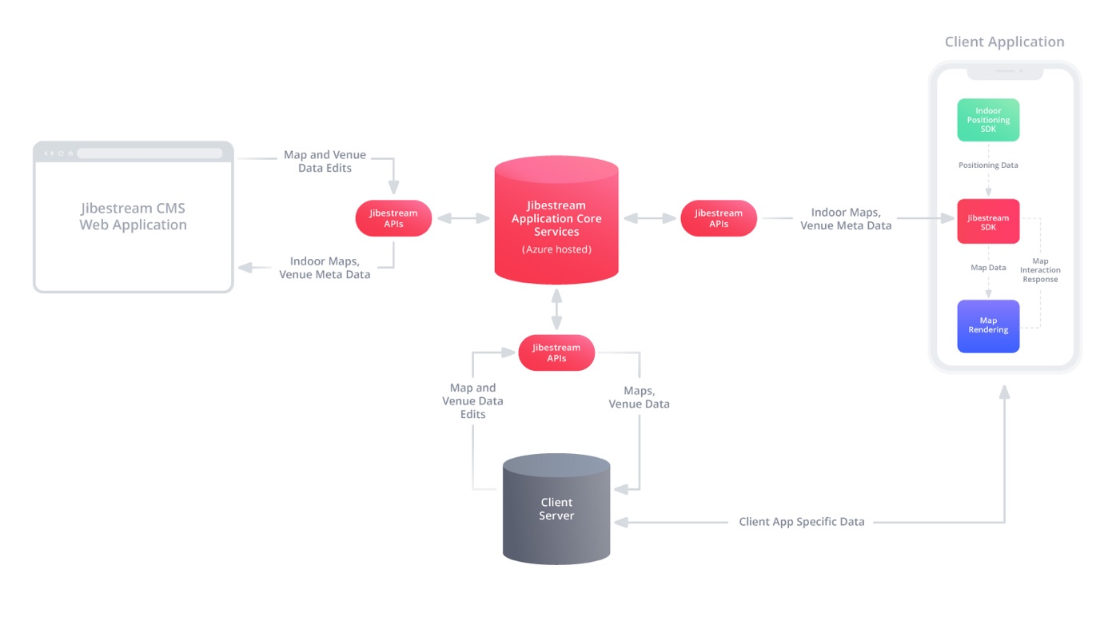

We prefer that the solution be deployed on cloud, but we can offer On-Prem solutions as well, however that will come at a higher cost for the initial setup.

* Do they provide indoor mapping as an API service to be consumed by other applications?

Yes. Our indoor mapping platform consists of Native SDKs (iOS, Android, Web), APIs, and CMS.

* Any restrictions on loads e.g. 50K customers trying the service from multi-channel?

Our platform is tested for loads at 100 x black Friday amounts. There will be no restrictions if 50k customers are trying the service from multiple channels.

* How user friendly will this be to create a new floor map for a new store by IKEA co-worker/admin? Please elaborate with some relevant data point on this from other Jibestream customer reference(KPI eg. Total sq m, days of end user training, throughput etc).

We recommend that for any “Net New” store, we create the first map, and then the maintenance (including minor structural changes) be done by Ikea. Assuming that we will generate those new floor maps, we can digitize it within a week to 10 days.